**Experiment No. 2**

Aim: To use basic networking commands in Linux (ping, tracert, nslookup, netstat, ARP, RARP, ip, ifconfig, dig, route )

Requirements: Windows/Linux/MAC OS in PC/Laptop, compatible version of terminal in OS.

Theory:

|  |  |
| --- | --- |
| Networking commands | Operations |
| ping(packet internet groper) | This command is used to check the network connectivity between host and server/host. |
| tracert(trace route) | It’s used to show the path from the source computer to the destination computer |
| **nslookup(name server lookup)** | It translates a domain name to an IP address and vice versa |
| netstat | Displays active TCP connections, ports on which the computer is listening, Ethernet statistics, the IP routing table, IPv4 statistics (for the IP, ICMP, TCP, and UDP protocols), and IPv6 statistics (for the IPv6, ICMPv6, TCP over IPv6, and UDP over IPv6 protocols). |
| arp(address resolution protocol) | Displays and modifies entries in the Address Resolution Protocol (ARP) cache. |
| rarp | RARP provides the opposite service to ARP in that it is used when only the ethernet address is known and the IP address is needed. |
| ip | This is used to assign an address to a network interface and/or configure network interface parameters on Linux operating systems |
| ipconfig/ifconfig | Displays all current TCP/IP network configuration values and refreshes Dynamic Host Configuration Protocol (DHCP) and Domain Name System (DNS) settings |
| dig(domain information groper) | The dig command, allows you to query information about various DNS records, including host addresses, mail exchanges, and name servers. |
| route | Displays and modifies the entries in the local IP routing table. |

Commands and Output:

ping:

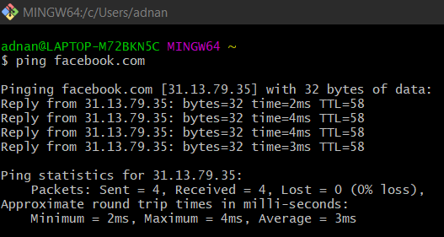

tracert:

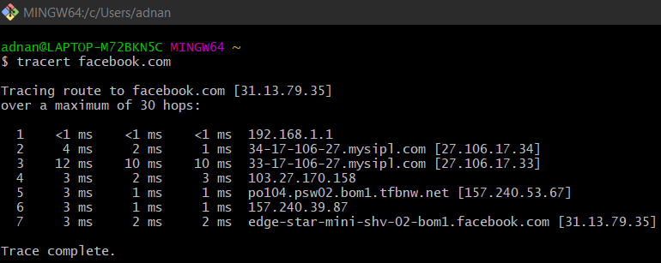

nslookup:

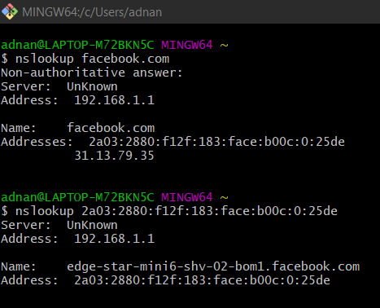

netstat:

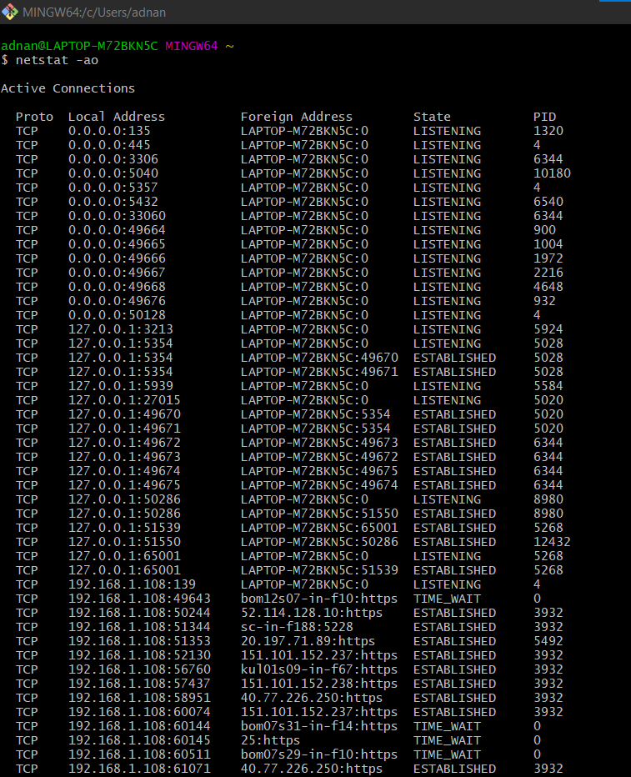

arp:

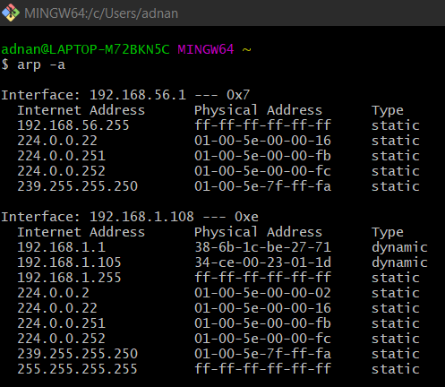

ip: 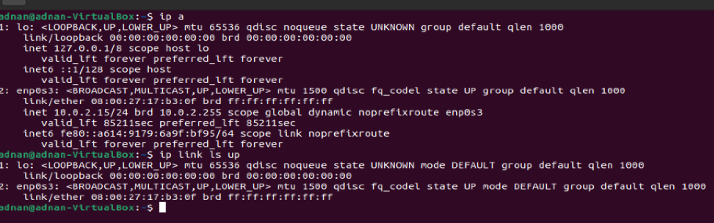

Ipconfig/ifconfig:

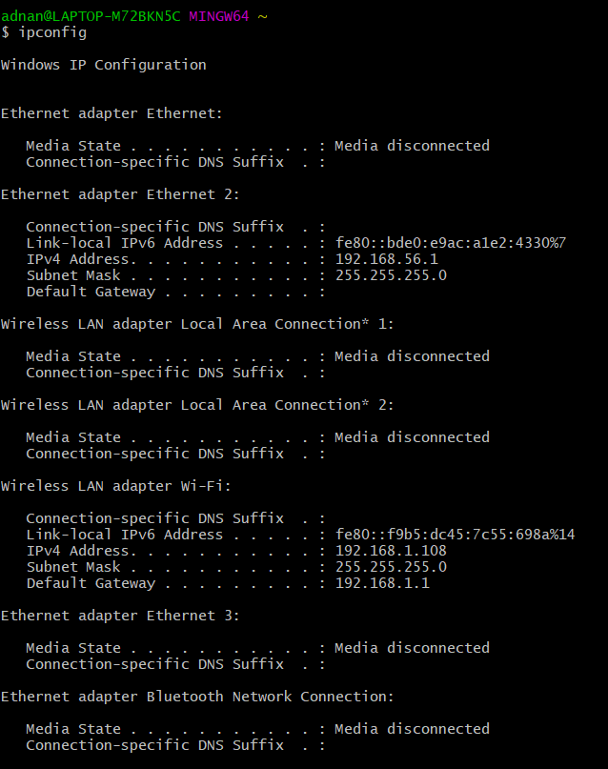

dig:

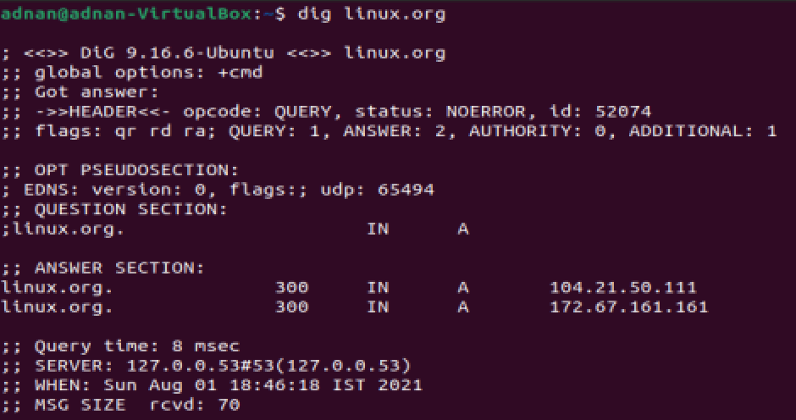

route:

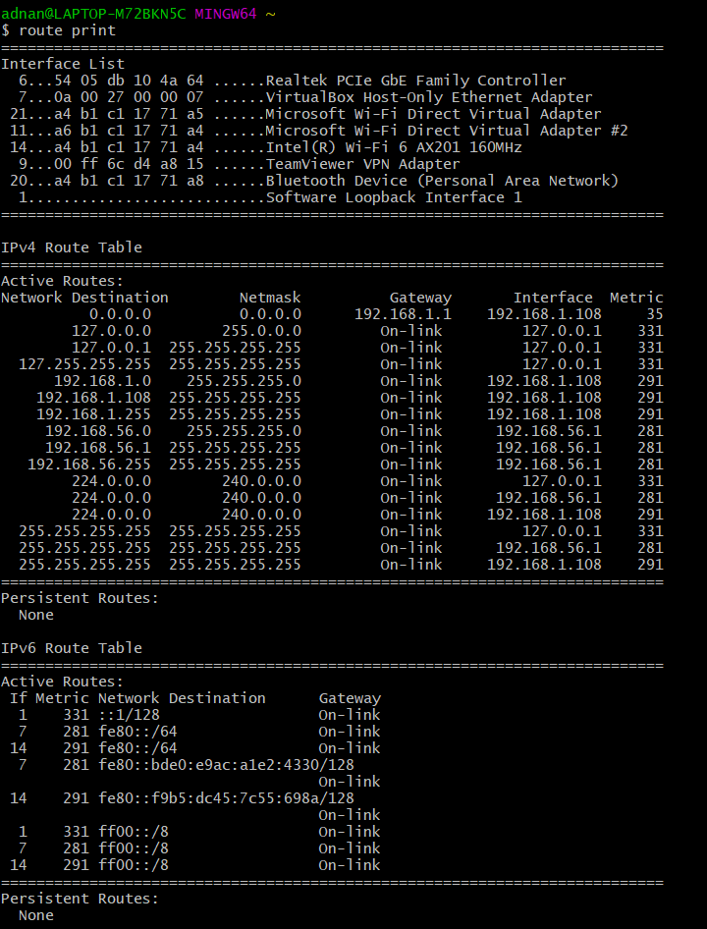

Conclusion: We have successfully executed and got the output of basic networking commands (ping, tracert, nslookup, netstat, ARP,RARP, ip, ifconfig, dig, route ) in Linux Shell.